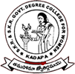 | SKR & SKR GOVT. COLLEGE FOR WOMEN (A), KADAPA  Reaccredited with ‘B’ grade by NAAC

Programme Photos:
29.07.2021 AWARENESS PROGRAMME ON DISHA APP

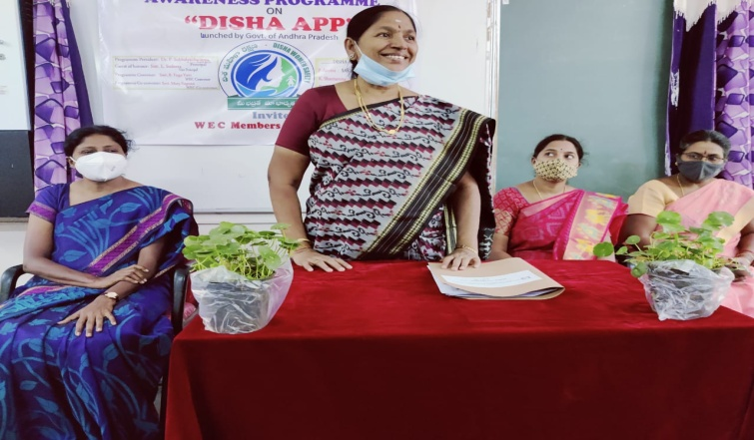 | 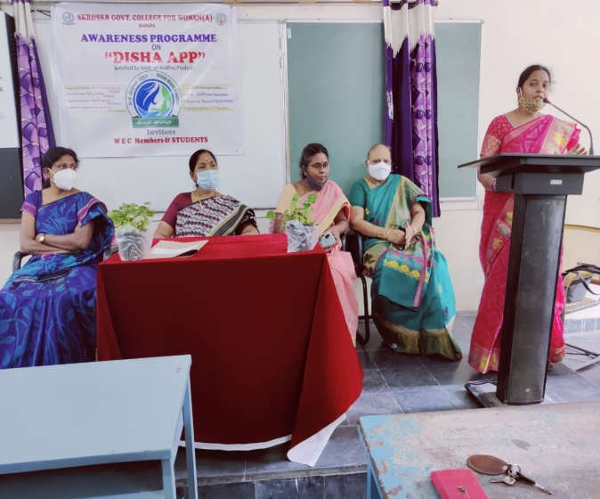
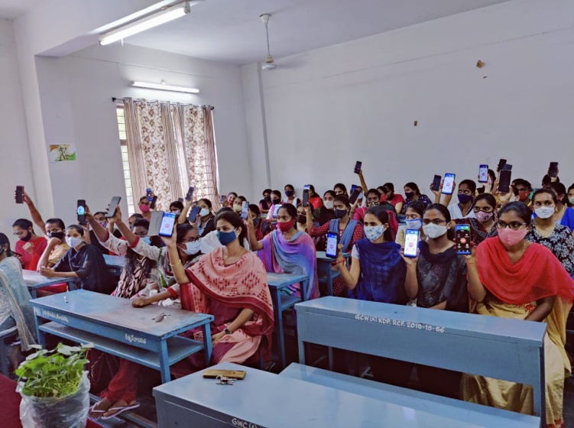 | 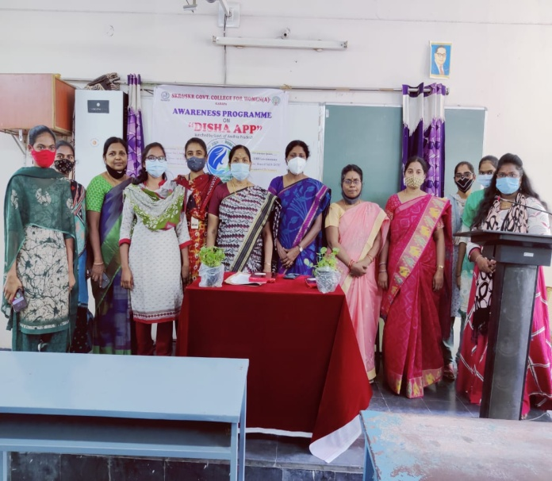
An Awareness Programme on DISHA APP organised by Women Empowerment Cell on 29.07.2021. Smt B.Yugavai coordinator of Women Empowement Cell. Dr P.Subba Lakshumma, Principal told the awareness on Disha app. P. Aswini, Administrator and K. Santhamma Woman SI. Sakhi Centre, Kadapa attended as resource persons and created awareness on Disha app and usage. Students downloaded DISHA App. All the Women staff and students participated in this programme.

Vaccination programme
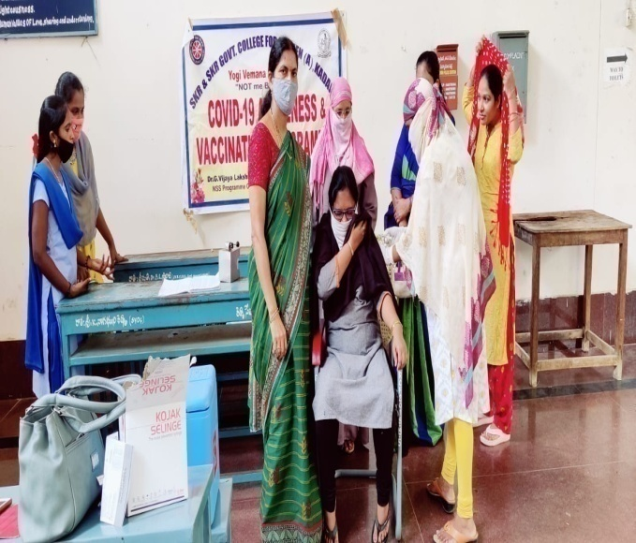 | 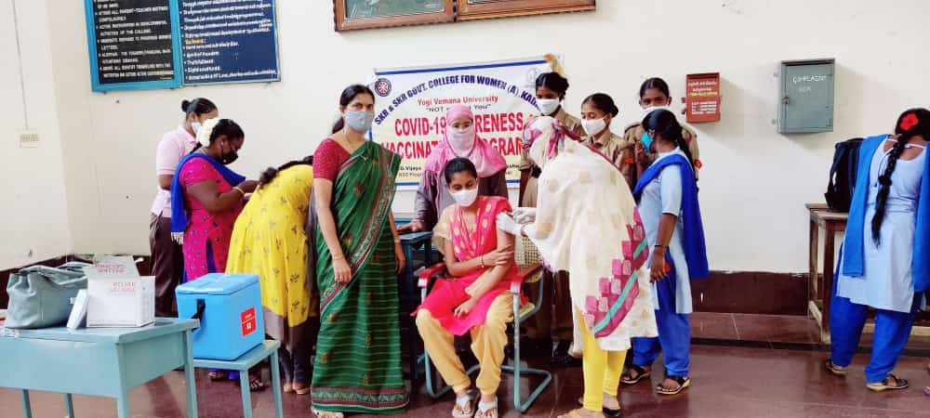
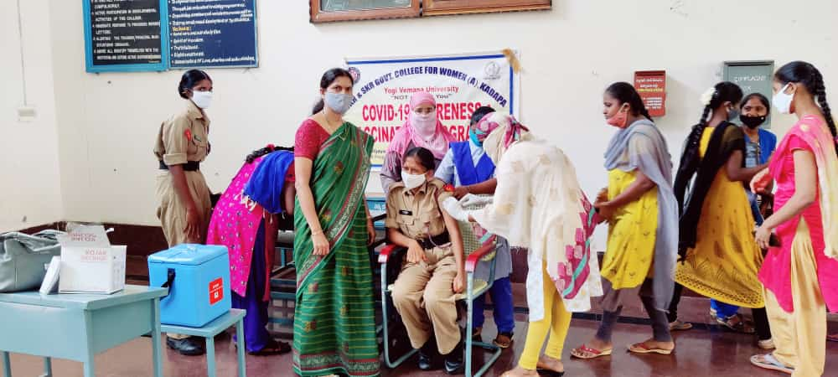 | 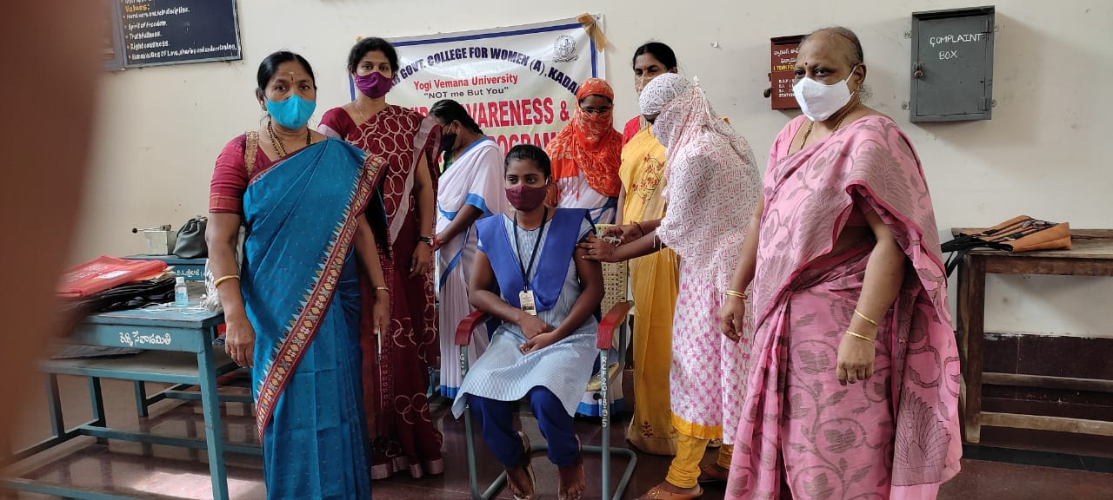
DrG.Vijaya Lakshmi Devi, NSS programme officer conducted Vaccination programme on 03.09.2021. DrP.SubbaLakshumma, Principal explained the importance of vaccination during the spread of Covid-19 pandemic situation and told that the only way to prevent corona virus is by getting vaccination of 2 doses. Staff and students vaccinated on this occasion.

AWARENESS PROGRAMME on health
organised BY AYUSH DEPARTMENT
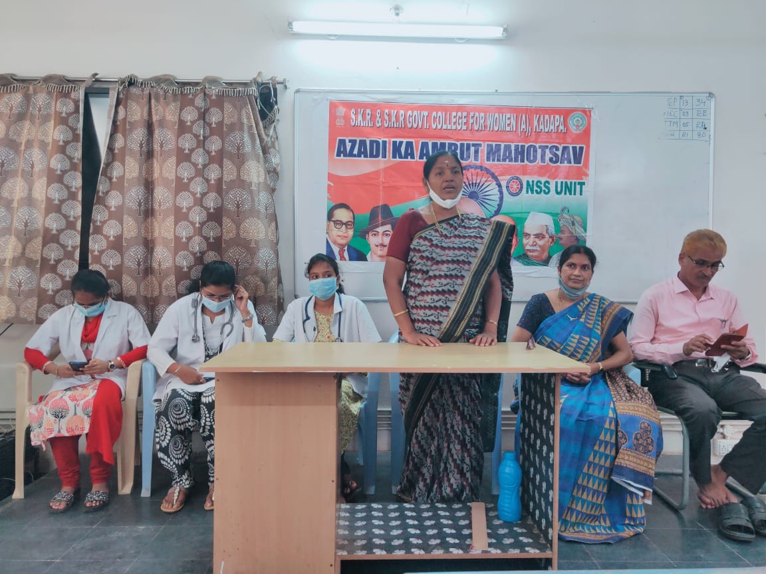 |  | 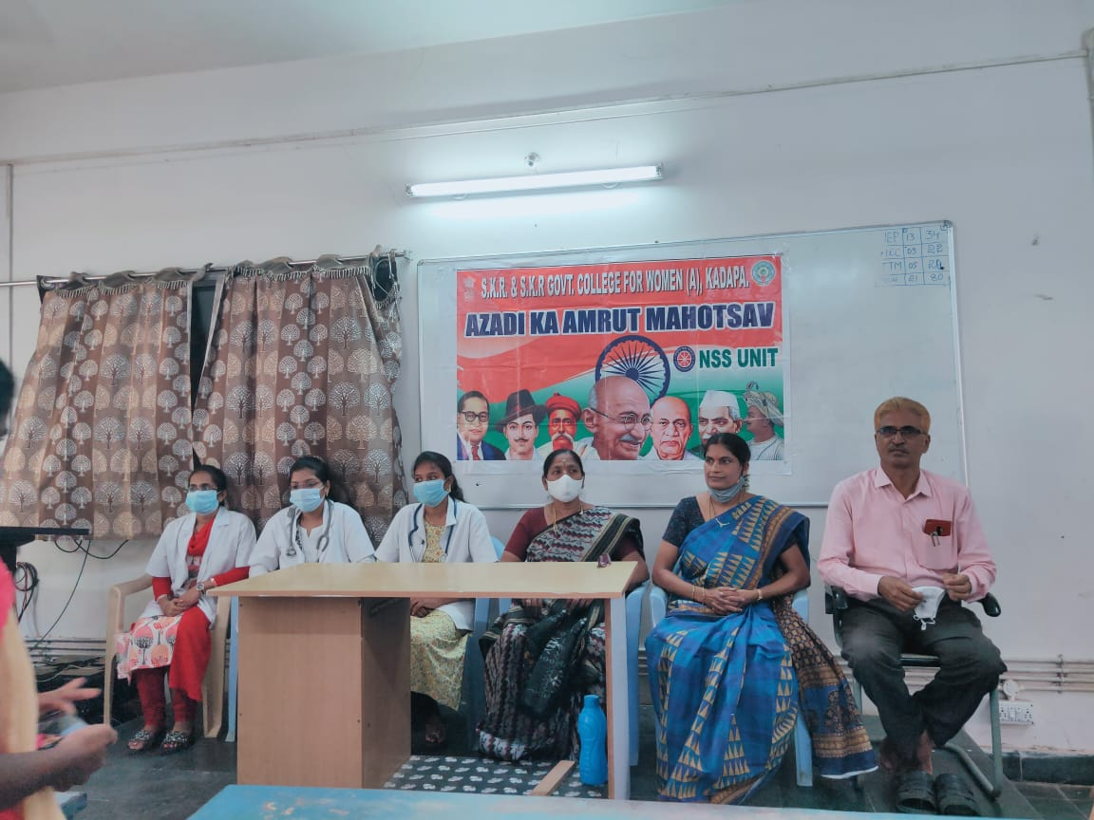
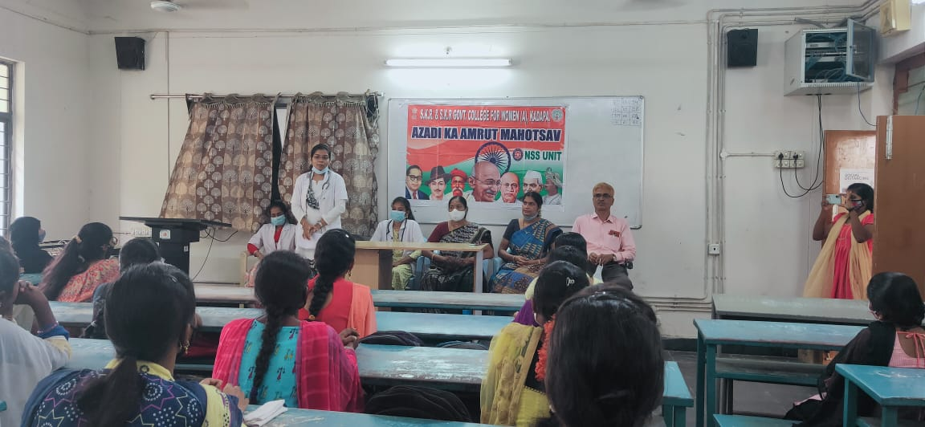 |  | 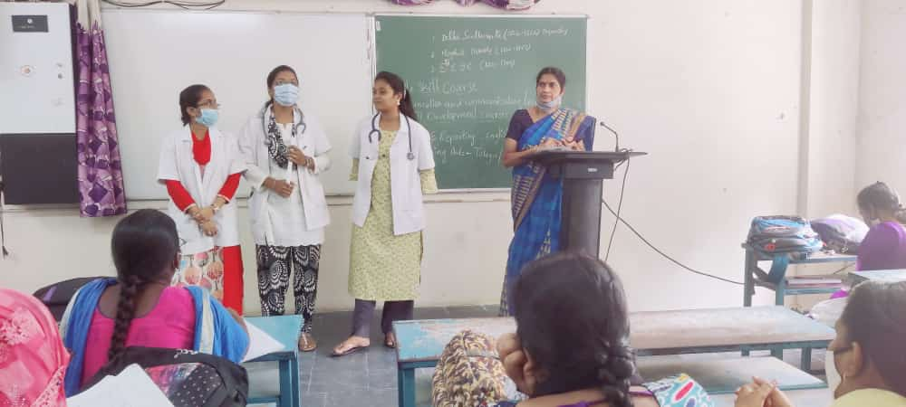
On the occassion of Azadi Ka Amrit Mahotsav Dr G.Vijaya Lakshmi devi, NSS Programme Officer organised an awareness programme on Health organised by Ayush Department, Kadapa on 04.09.2021. Dr P.Subba Lakshumma, Principal explained in detail about the healthy living and prevention of diseases. Dr G.Vijaya Lakshmi Devi explained about the functions of Ayush Department to strengthen the implementation of National and community health programmes. Students and NSS volunteers participated in this programme.

SELF DEFENCE training programme

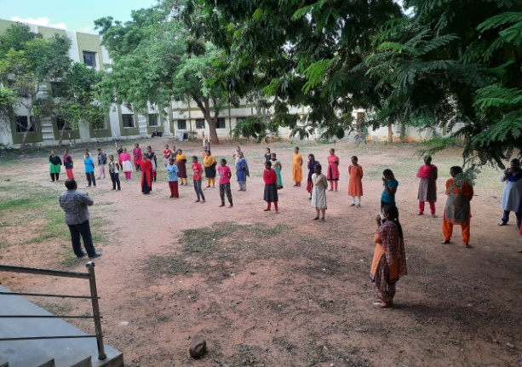 |  | 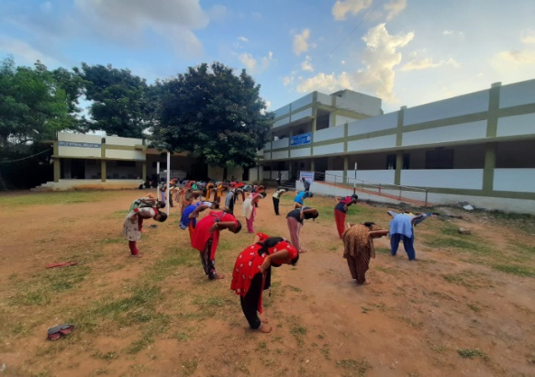
Sri K. Madan Mohan, Physical Director organised self defence training programme to woman students from 17.09.2021 to 01.10.2021. Dr P.Subba Lakshumma, Principal Inaugurated the programme. Sri MVijayabhasker reddy TEAKWONDO MASTER is the trainer of the programme. Students actively participated inthis programme.
CAREER GUIDANCE CLASS

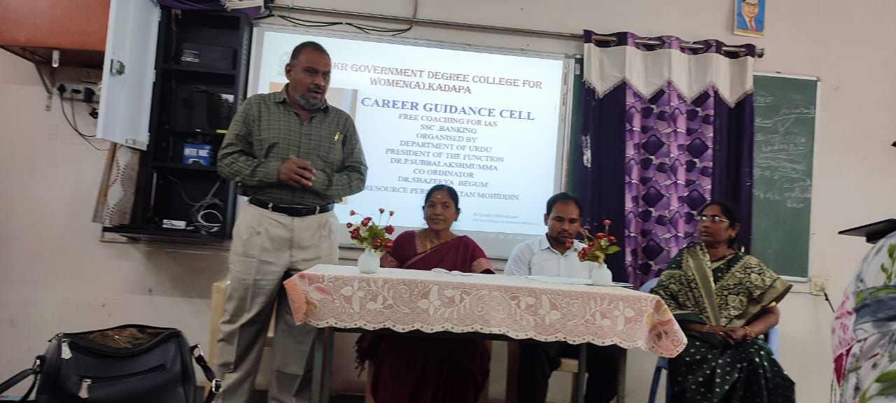 | DrShazeeya Begum, Coordinator of Career Guidance Cell organised Career Guidance class to BA students on 02.11.2021. Dr P. SubbaLakshumma, Principal inaugurated the function and explained in detail about the Job opportunities after graduation. Sri Sultan Mohiddin, MS academy attended as Resource person and taught the Job opportunities and employability skills after Graduation.
AWARENESS PROGRRAMME ON CYBER CRIMES
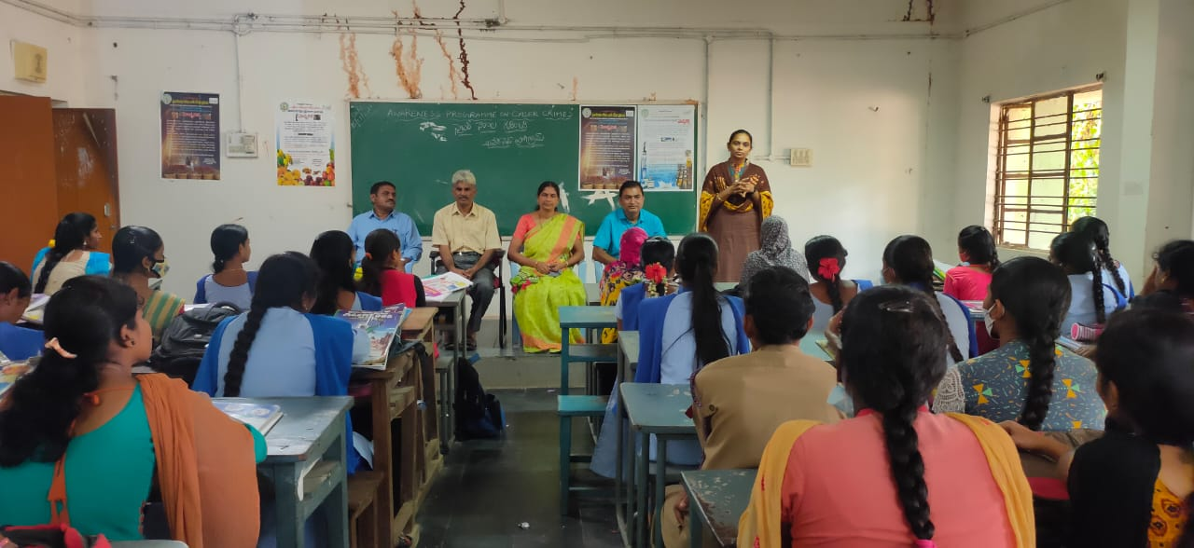 |  |  | Awareness program on CYBER CRIMES was organised by Department of Economics with the cooperation of Women Protection cell kadapa,on 15.11.2021. Smt Shakuntala, World woman protection secretary, kadapa attended as chief guest and explained in detail about the cyber crimes. Dr. G. Vijay Lakshmi, T. Sreenivasu Reddy & Dr. M. Guru Mohan Reddy and students participated in this programme.

Rally on world aids day
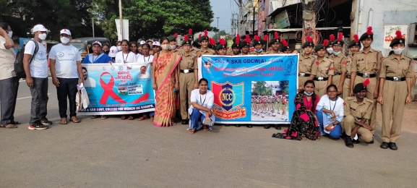 | 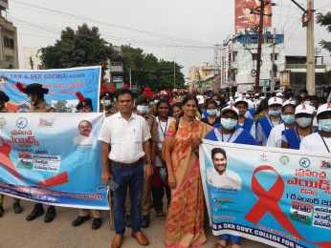
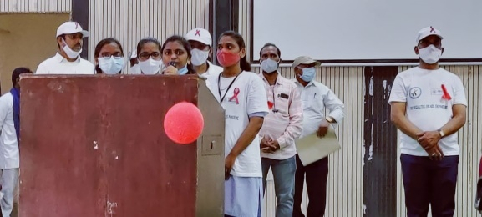 | 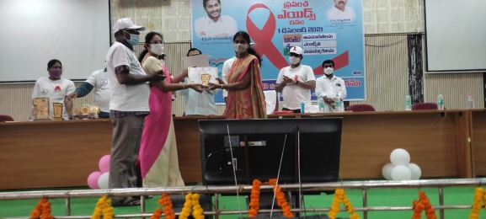
On the occasion of World Aids day on 01.12.2021, Dr G.Vijaya Lakshmi, NSS Coordinator organised a rally from College to Collectorate office, All NSS Volunteers participated in this programme. Yamini II B.A student sung a prayer song at Collectorate Office meeting. District Legal Services Authority distributed participation certificate.

 | RRC HEALTH AWARENESS PROGRMME
 | 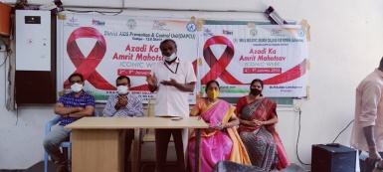 | 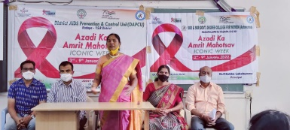
 | RRC organised health awareness programme on 07.01.2022 on the part of AzadikaAmritMahotsav. Dr P. SubbaLakshumma presided the meeting, Sri Khadarvalli, Additional DMHO attended the programme and created awareness on Health to the students. Staff and students participated in this programme.
WORLD CANCER DAY 04.02.2022
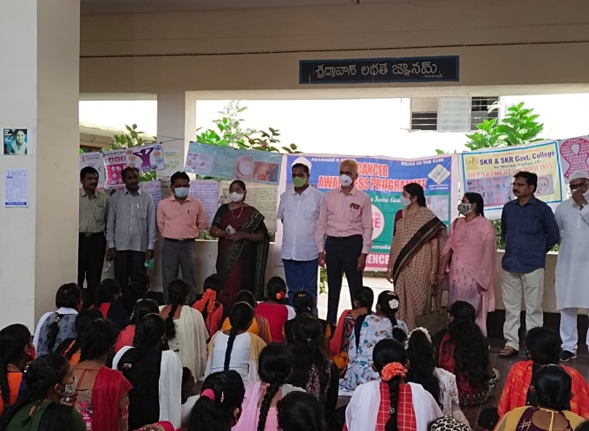 |  |  | 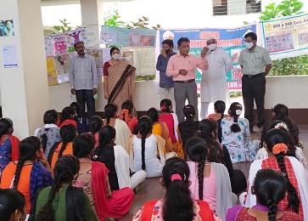
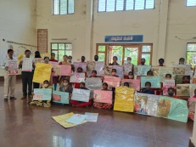 |  |  | 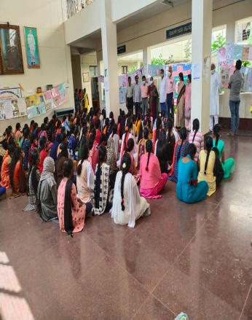
On the occasion of World Cancer Day the department of Zoology conducted an awareness programme on 04.02.2022. Dr P. Subba Lakshumma, Principal explained about the causes of cancer and prevention steps to control the cancer. Sri R. Sreenivasula Reddy, School Assistant, Biological Science, ZPJS School, Chapadu, C.V Raman, Science Club, Kadapa Division President attended as a Chief guest and explained about the History, signigicance and theme of the Cancer day. Dr P. Sachi Devi, Lecturer in Zoology coordinated this programme. Faculty of Zoology and Students participated in this programme.

NATIONAL DEWARMING DAY ON 03.03.2022

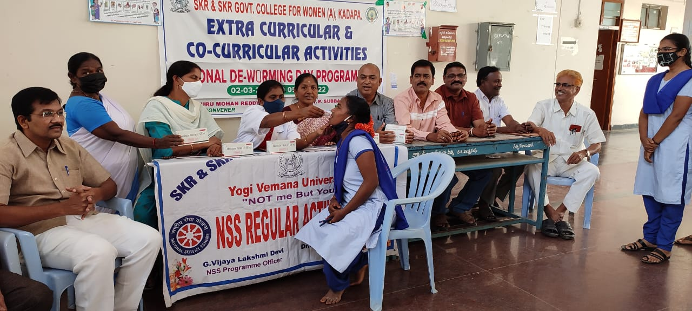 | 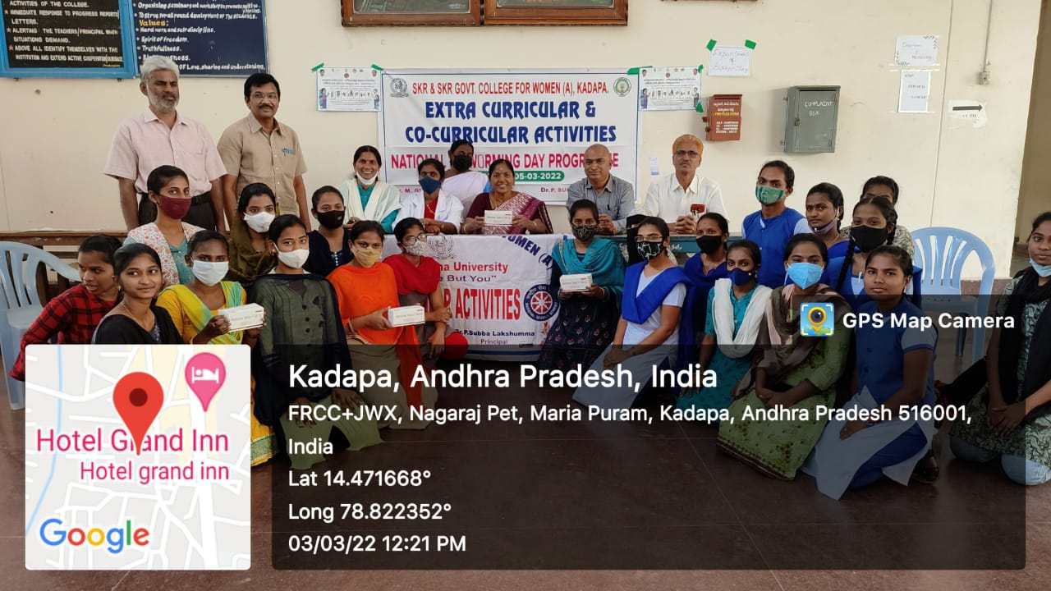
On the occasion of National De-warming day Sri M. Guru Mohan Reddy, Convenor of Extra Curricular Activies conducted an awareness programme on 03.03.2022.. Dr. Haseena, MBBS, UPHC, Nagarajpet, Kadapa and Dr. Kavya, MD, PP Unit have attended and distributed Albendazole 400 mg oral tablets to students. Dr P. Subba Lakshumma, principal staff and students participated in the programme.

SAKHI ONE STOP CRISIS PROGRAMME BY WEC
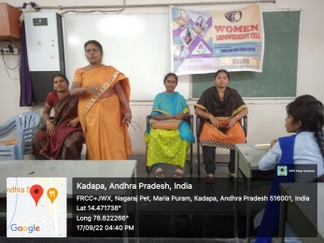 | 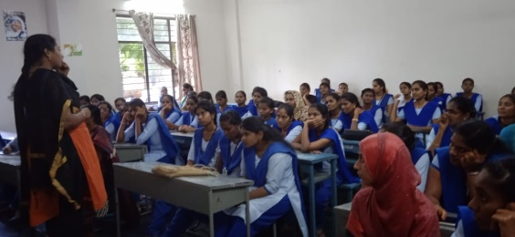
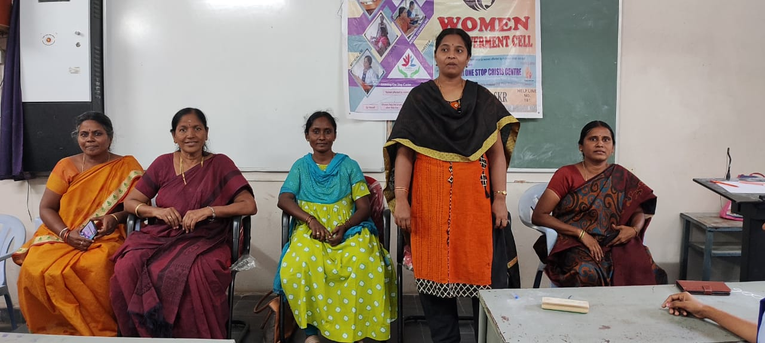 | 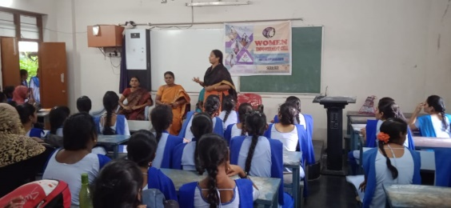
Smt B. Yuga vani, Women Empowerment Cell Convenor organised awareness programme on 17.09.2022 on Sakhi One Side Stop Crisis Program. Dr P. Subba Lakshumma, Principal inaugurated the meeting. Sakhi Administration centre coordinator O.Aswini & P. Vijayalakshmi attended as Resource persons and explain the objectives of Sakhi programme and created awareness. Students and Women Empowerment Cell members participated in this programme.

DEWORMING DAY
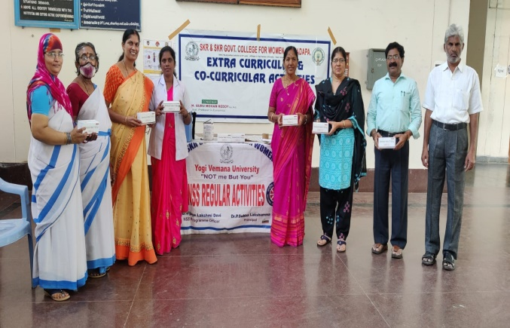 | 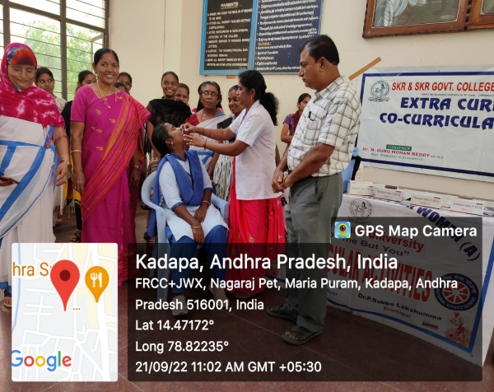
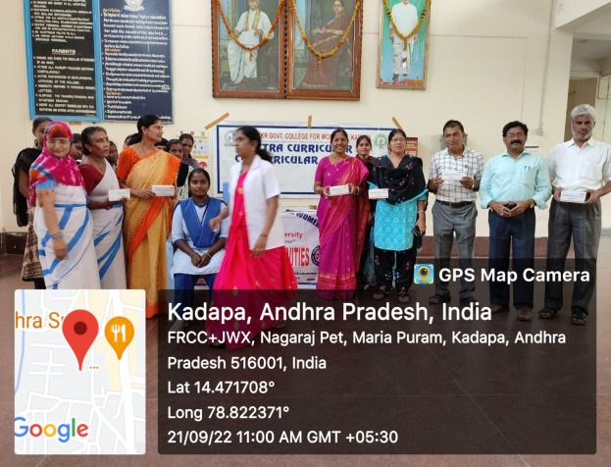 | 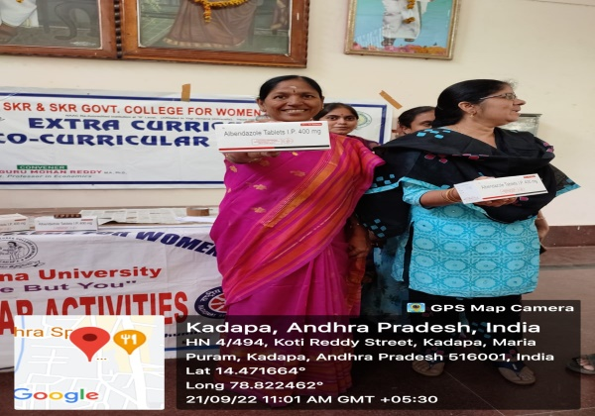
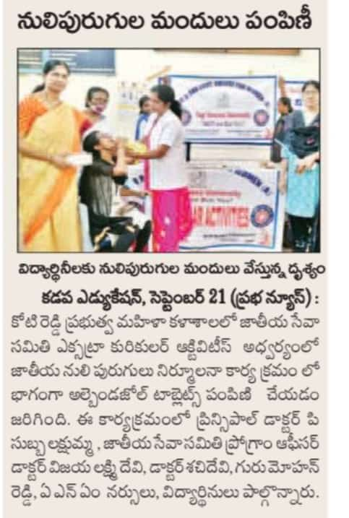 | 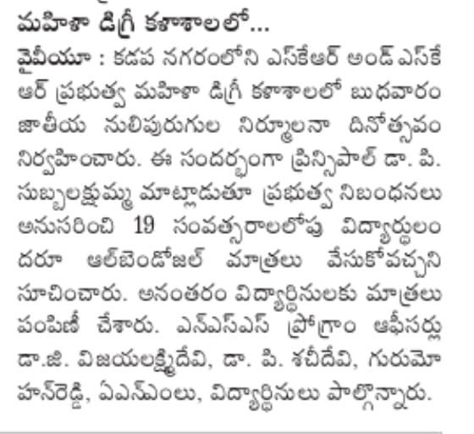
On the occasion of Deworming Day on 21.09.2022 NSS units of the college organised awareness programme. Dr P. Subba Lakshumma, Principal distributed Albendazole tables to students with colloboration of DMHO AMM nurses. NSS cadets and staff participated in this programme.

WORLD HEART DAY POSTER PRESENTAtION
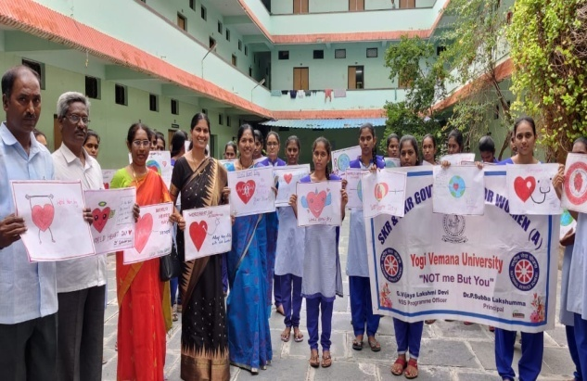 | 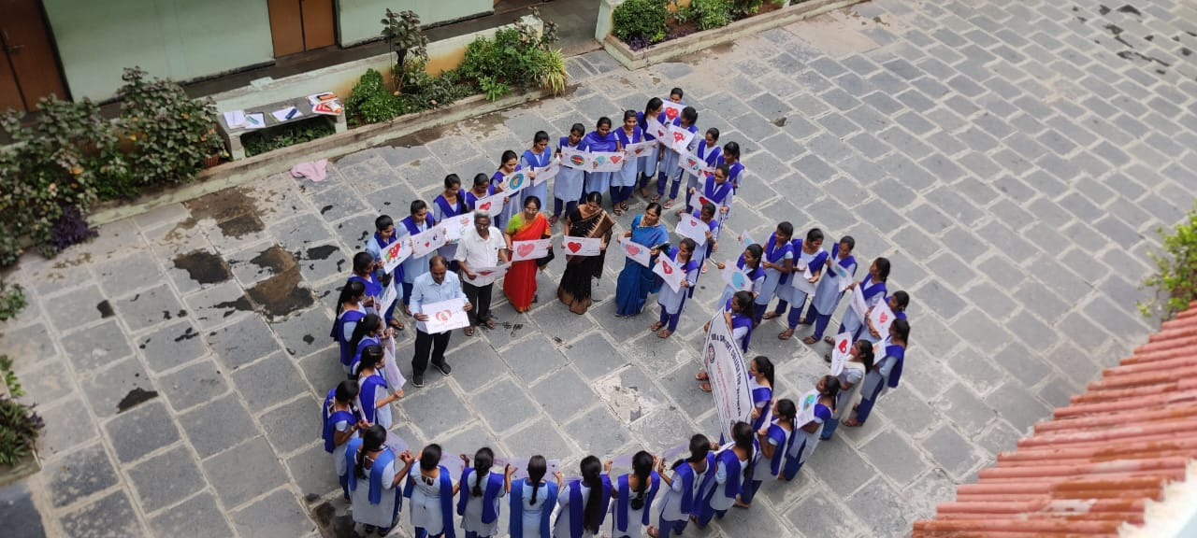
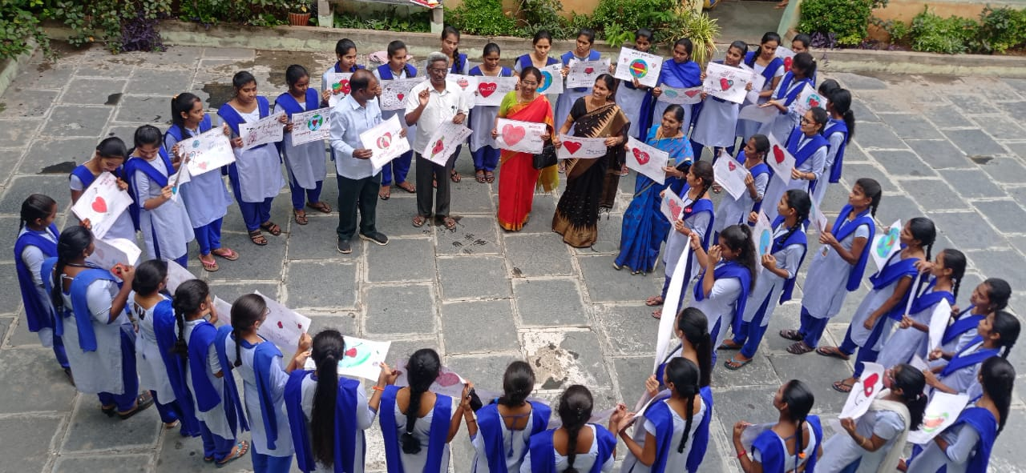 | 